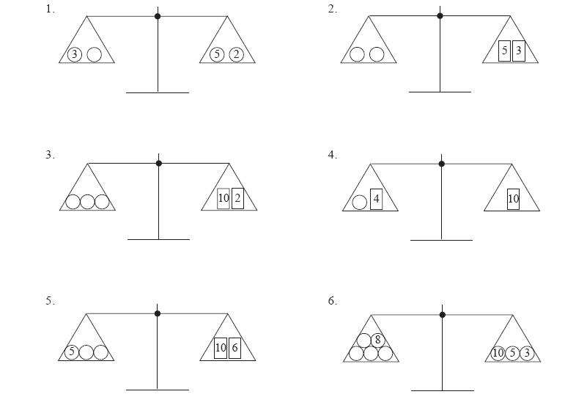

*x* + 3 = 5 + 6

*x* + 3 = 11

*x* + 3 = 8

3

5

10

8

55

3

1

5

6

5