Common Core Math 8 Name_____________________
Unit 8 3D Volume Project
Building a Structure
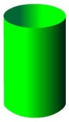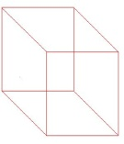

Objective: Students will be able to measure, calculate and explain the process for finding the volume of a rectangular prism and a cylinder.
Directions:
Part 1:
1)Locate or Build a rectangular prism. Measure the dimensions and calculate the volume of the figure.
2) Locate or Build a cylinder. Measure the dimensions and calculate the volume of the figure.

Part 2:
Decorate the 2 figures with the information it took you to calculate the volume. MUST INCLUDE THE VOLUME FORMULA FOR THAT FIGURE. Check your work with 3 other students. Make necessary corrections. Rubric must be placed firmly on the object.

Part 3:
You must go to at least 5 teachers NOT in the 8th grade hall and explain to them the process you went through to find the volume of both of your figures. Once the teachers feel like they understand they will sign your figures.

