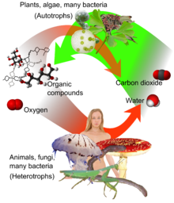
Name: ______________________________
Adopted from Ms. Bethel
Queensbury Middle School

Cell Respiration Webquest

Directions: Use the links provided throughout the quest to help answer the questions on this paper.

Part I: Function and equation for respiration:
- Click on the following links and use the information provided to write a
definition of cellular respiration in your own words.
- BioCoach: Cell Respiration
- Miller/Levine Book Resource

2. Write the chemical equation for cellular respiration.

Find the equation

What are the reactants?
What are the products?
Where have you seen something like this equation before? Explain.

3. How does the equation for cellular respiration compare with the
equation for photosynthesis?

5. What is ATP? Why is it an important product of cellular respiration?
- ATP Info

Part II: Main Site of Cellular Respiration:
Use the following link to answer questions 8-10:
organelle of respiration

8. What is the main site of respiration in the cell?

9. Draw a picture of the respiration site
and label major parts on the right.

10. What energy molecules are produced in this
respiration organelle?
- anaerobic vs. aerobic: Buzzle article
11. What is the difference between aerobic and anaerobic cellular
respiration?

12. Click on the “Cellular respiration” link and scroll down to
fermentation.
- Cellular respiration
What is lactic acid fermentation? Where does it occur?

13. What does a build up of lactic acid cause?

14. What is alcoholic fermentation?

15. In what industry is alcoholic fermentation important?

Part III: Summary:
17. Write a summary of cellular respiration. In your response:
  - State the function of cellular respiration
  - Identify the site of cellular respiration
  - Compare aerobic and anaerobic forms of cellular respiratio

